**III - DISCUSSION OF FINDINGS**

This section discusses the findings of this study. It involves the problems encountered and the current procedures in teaching the topic The Universe and the Solar System using the existing materials. According to Ms. Ely Aragon, the teacher interviewed by the proponents, Audio Visual Presentations, PowerPoint Presentation and books play an important role in teaching the topic. With these, the lesson is presented with slides, videos or digital arrangements. During the presentation of the lesson the teacher provides additional information (i.e. current events, trivia facts, etc.), reinforces key points, and involves the learners in the discussion. The Panpacific University North Philippines Tayug Campus is currently conducting online classes due to the pandemic.

According to Ms. Ely Aragon, in the School of Basic Education, they are utilizing Google for Education as their partner in their Online Home Learning Program (OHLP). With this, they are conducting their classes via Google meetings. They also have the OHLP Primer which was issued to the parents and students before the classes started. This serves as their guide for Distance Learning.  The school program is divided in Day 1 & Day 2 schedules with synchronous time in the morning and asynchronous time in the afternoon.

Learning Packets. This learning packets or modules are prepared by the teacher and is being uploaded weekly. This learning modules allows the students to explore the content in any order or at their own pace. Sending of Individual Learning Monitoring Plan (ILMP) to the parents is also done weekly for them to be informed of the Academic & Behavioural Status of their children during the Online Home Learning Program.

Giving of Report Cards. Report cards are a great way for parents to know how their child is performing in school. The purpose of report cards is to convey information from the school to parents about a student's educational progress. Distribution of report cards quarterly are all done virtually.

 These are the existing materials and current procedures conducted in teaching the topic The Universe and the Solar System. According to the teacher, these materials are effective in teaching the topic, but problems such as the students having difficulties in class participation and in understanding the lesson very well is quite inevitable.

The developed e-learning mobile application is the upgraded version of the Audio Visual Presentation, PowerPoint Presentation and other existing materials used by the teacher in teaching the Universe and the Solar System. The mobile application runs only in android operating systems versions 7 and up. The system will serve as an additional learning material of the children to improve the quality of learning and also to provide convenience to the teachers. The general features of the system are the e-lessons, virtual reality viewing of planets and the virtual reality quiz. These features will be furtherly discussed in the next section of the document.

**Features of the Proposed System**

Based from the previous objective, the following features were incorporated in the proposed system: Integration of e-Lessons, VR Multimedia Section and VR Quiz

E-Lesson. This feature of the system allows the user to choose any planet from the solar system or any object in the universe and the system will exhibit a lesson about the chosen planet or object. The lesson is purely based from the book of Grade-6 students used as a reference in teaching the subject.

In this feature, the user will choose what lesson they want to view by simply clicking on the planets or objects listed as shown in Figure 3. Afterwards, the lesson about the chosen planet will appear as shown in Figure 4.

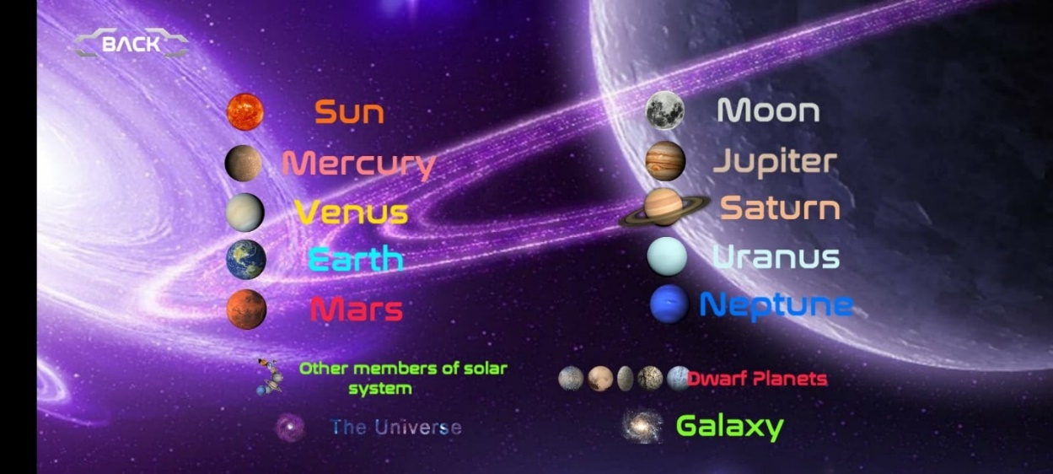

Figure 3. E-Lesson Selection Interface

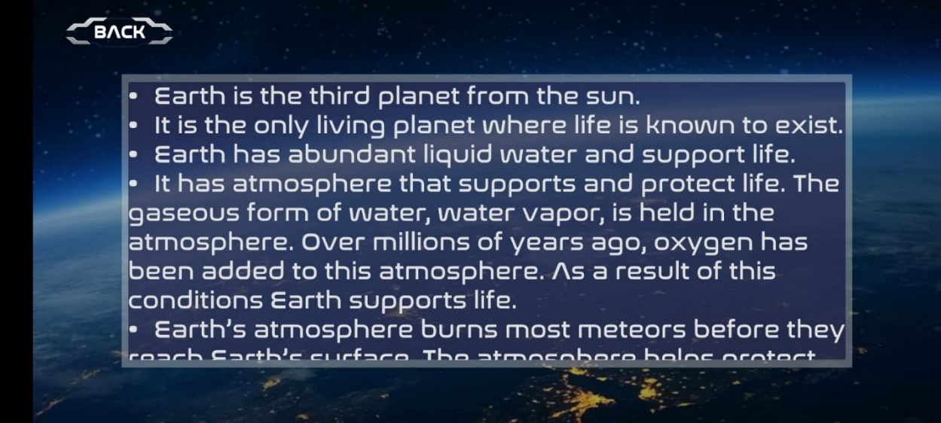

Figure 4. e-Lesson

Virtual Reality Multimedia. This feature allows the users to view the solar system and the Universe virtually using VR Box or VR Glasses. Aside from the view of each planet, this feature is also incorporated with an audio that states a short information about the planet that was selected by the user.

In this feature, the user will click the “explore” button as shown in Figure 5 in order to proceed to the virtual reality viewing section as shown in Figure 6. The proponents highly recommend the users to use VR Box or VR Glasses for better experience. The user will use the blue reticle dot provided by the system as a cursor in choosing a planet they want to view. Upon hovering the cursor in a certain planet, the system will automatically play an audio stating a short information about the planet.

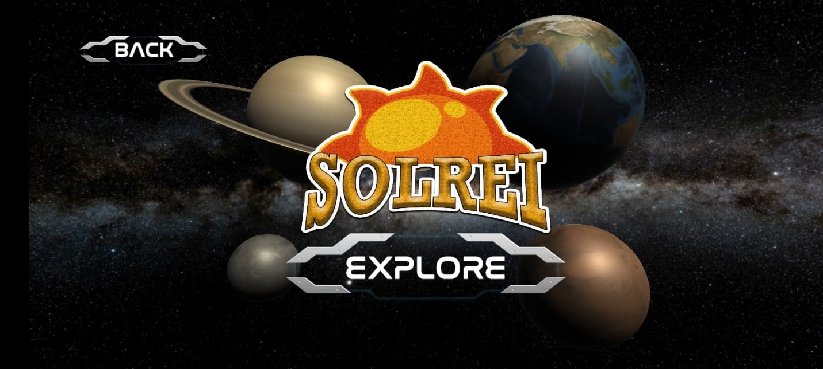

Figure 5. Virtual Reality Menu

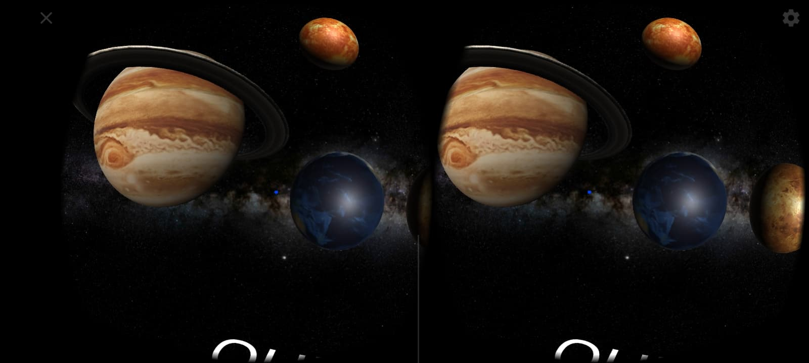

Figure 6. Virtual Reality Environment

Virtual Reality Quiz.This feature allows the user to take multiple choice type of quiz in the form of virtual reality to make it more interactive. This feature will assess what children learned in the subject.

Below the virtual view of the planets, the user will see “QUIZ” and “HOME” buttons. To proceed to the virtual reality quiz section, the user will need to focus the blue reticle dot to the quiz button and in approximately three seconds, the first question of the quiz will appear. It is a multiple choice type of quiz so the procedure will apply to all the questions provided until the user finishes the quiz. Just focus the blue reticle dot on your answer for at least three seconds at every question. At the end of the quiz, the system will show your score and the best score recorded in the database of the system.

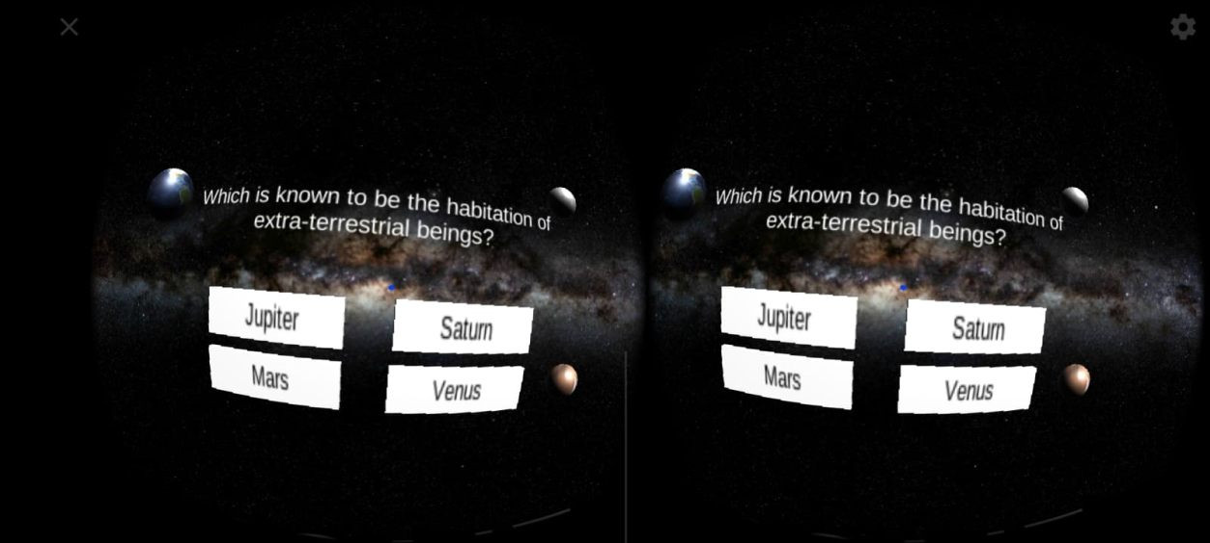

Figure 7. Virtual Reality Quiz

**Level of User Acceptability**

To test the level of user acceptance of SOLREI Mobile Application, the proponents created a Google Form for questionnaire and distributed it to the grade – 6 students of Panpacific University North Philippines to enable them rate the mobile application.

|  |  |
| --- | --- |
| **Scale** | **Interpretation** |
| 3.25 – 4.00 | Highly Accepted |
| 2.50 – 3.24 | Moderately Accepted |
| 1.75 – 2.49 | Accepted |
| 1.00 – 1.74 | Not Accepted |

The proponents used the Google Form containing the user acceptability questionnaire to the Grade – 6 students of Panpacific University North Philippines to test the level of user acceptance. The grade-6 students rated the mobile application as Highly Accepted with the average weighted mean of 3.45.

|  |  |  |
| --- | --- | --- |
| Description | Weighted Mean | Descriptive Equivalent |
| The learning objectives are clearly stated in each category | 3.22 | Moderately Accepted |
| The scope of the lesson is clearly stated | 3.33 | Highly Accepted |
| The organization of each category is easy to follow | 3.44 | Highly Accepted |
| The structure keeps me focused on what is to be learned. | 3 | Moderately Accepted |
| The problem is clearly stated in my subject | 3.22 | Moderately Accepted |
| Activities are planned carefully | 3.44 | Highly Accepted |
| The program content is easy to understand | 3.44 | Highly Accepted |
| The presentation of the subject content is clear | 3.66 | Highly Accepted |
| The program originality and creativity in the visual design and layout | 3.66 | Highly Accepted |
| The colors used in the program is appropriate | 4 | Highly Accepted |
| The multimedia technology (example: graphics, sound) contributes to the affective appeal of the program | 3.66 | Highly Accepted |
| I enjoy learning in this program | 3.55 | Highly Accepted |
| I felt a sense of satisfaction and achievement about this program | 3.22 | Moderately Accepted |
| Learning to operate the program was easy | 3.33 | Highly Accepted |
| I was able to access the program materials without much difficulty | 3.55 | Highly Accepted |
| Average Weighted Mean | 3.45 | Highly Accepted |

Table 1. User Acceptability Table

**Level of System Acceptability**

The proponents used Google Forms containing the system acceptability questionnaire to the IT Professionals represented by the instructors of Panpacific University North Philippines to test the level of system acceptance. The respondents rated the mobile application as Moderately Accepted with the average weighted mean of 2.95.

|  |  |  |
| --- | --- | --- |
| Description | Weighted Mean | Descriptive Equivalent |
| The program is easy to start and close. | 4 | Highly Accepted |
| Accuracy of data/information. | 2.75 | Moderately Accepted |
| It is easy to navigate through the program. | 2.75 | Moderately Accepted |
| The icons are clear and intelligible for easy use and navigation. | 2.5 | Moderately Accepted |
| The grammar and the vocabulary used in the program is correct | 2.75 | Moderately Accepted |
| The program has unique identity (example: logo) | 2.75 | Moderately Accepted |
| The system contents can be easily understood by the users. | 2.5 | Moderately Accepted |
| The features of the system are easy to learn and are adoptable to the users | 2.5 | Moderately Accepted |
| The system has a user-friendly interface. | 2.5 | Moderately Accepted |
| The program is open for support and maintenance. | 2 | Accepted |
| The program is usable | 2.5 | Moderately Accepted |
| Average Weighted Mean | 2.95 | Moderately Accepted |

Table 2. System Acceptability Table